How to create the parameters for datasets and apply it

1. Create new pipeline add copy data using drag and drop
2. Create linked service exactly created previously
3. Now create new dataset to prameterize it prameterizing means not adding exact file name just giving parameter file name then mentioning exact file name in copy activity similarly we cn do for folder as well not only for file just like passing parmeters to function in python we are passing file name as parameter to dataset
4. Create dataset got to authors -> go to datasets

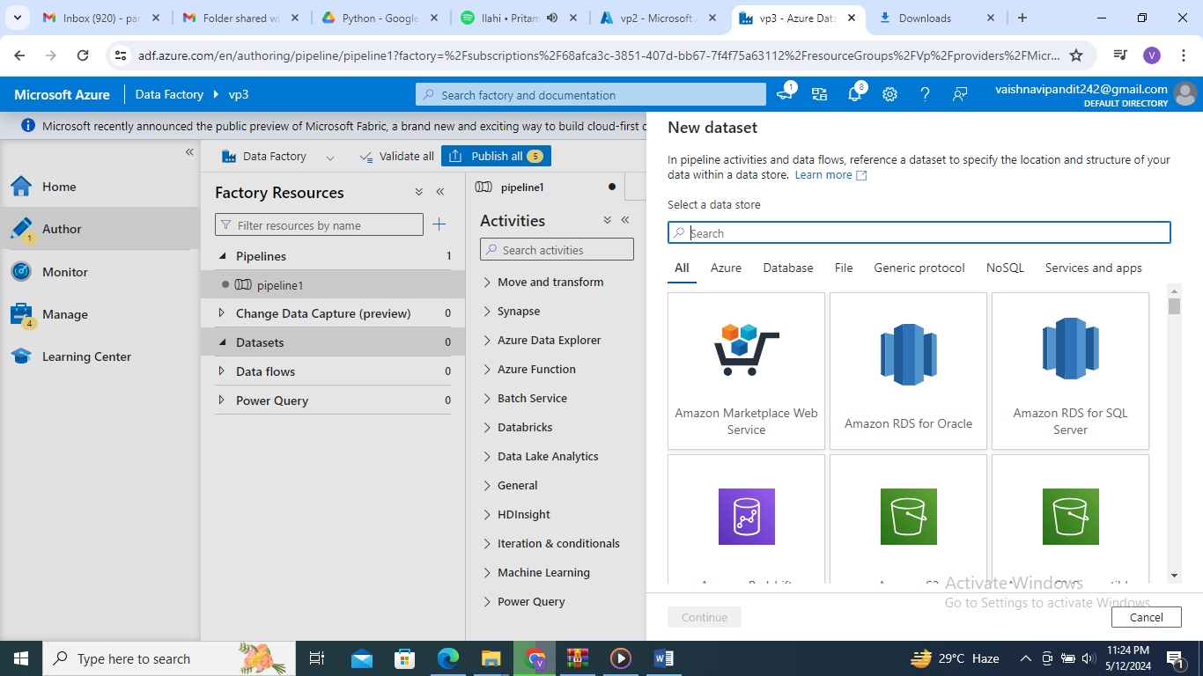

1. Select adls

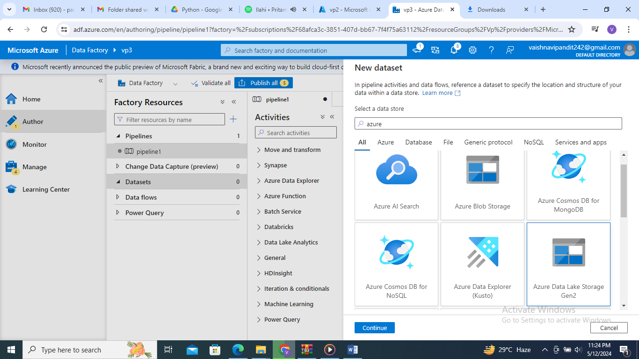

1. Select format
2. Add name

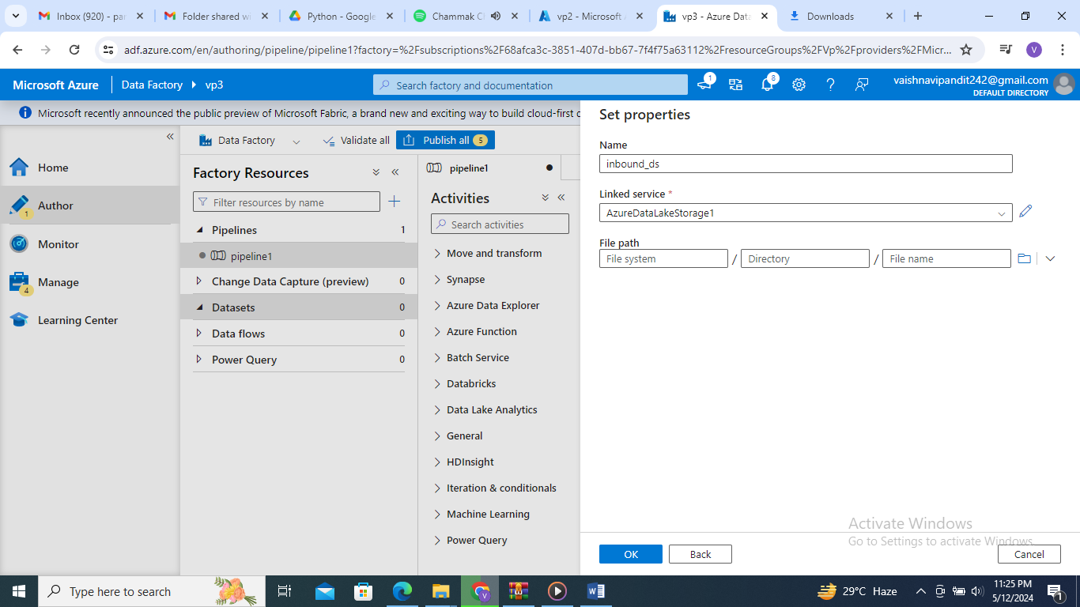

1. Add container name in file path

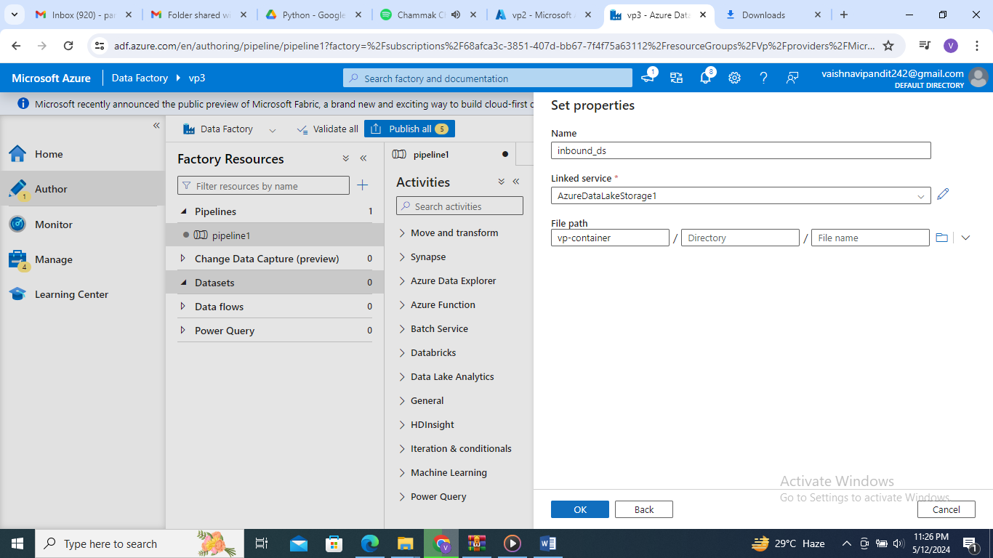

1. Now add parameters

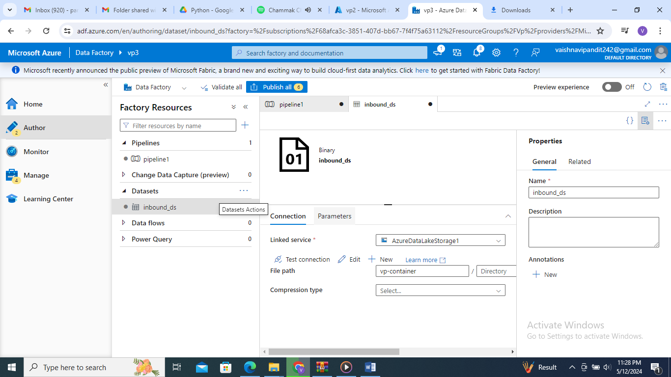

1. Create two parmeters 1 for folder 1 for file

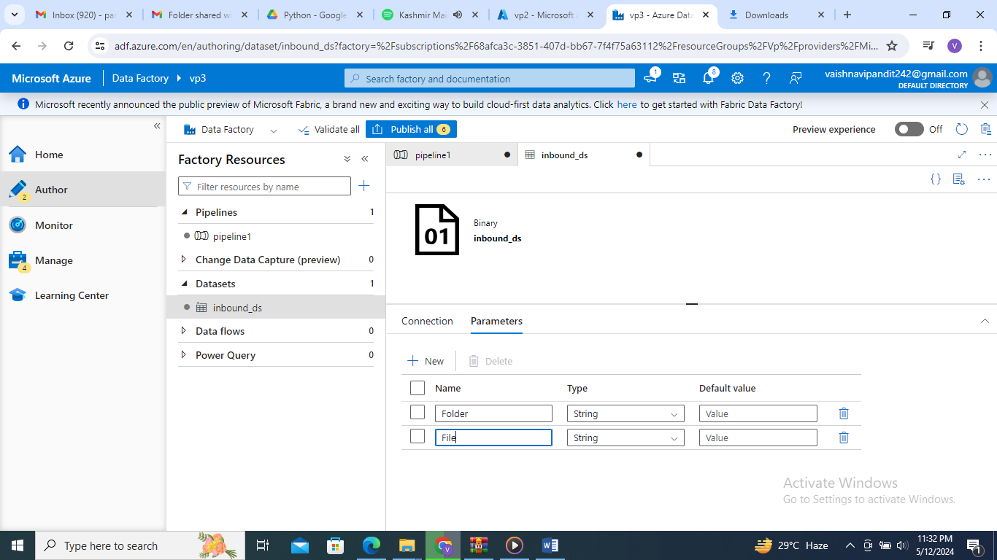

1. Now go to connects and add folder using add dynamic content

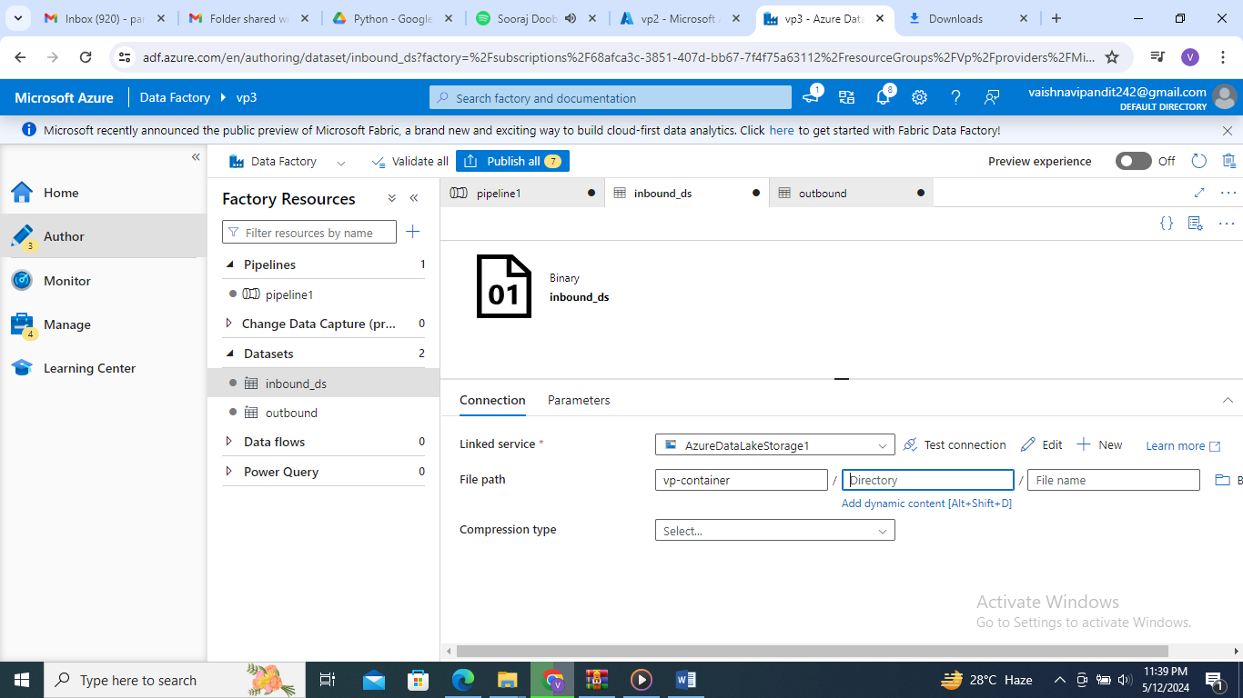

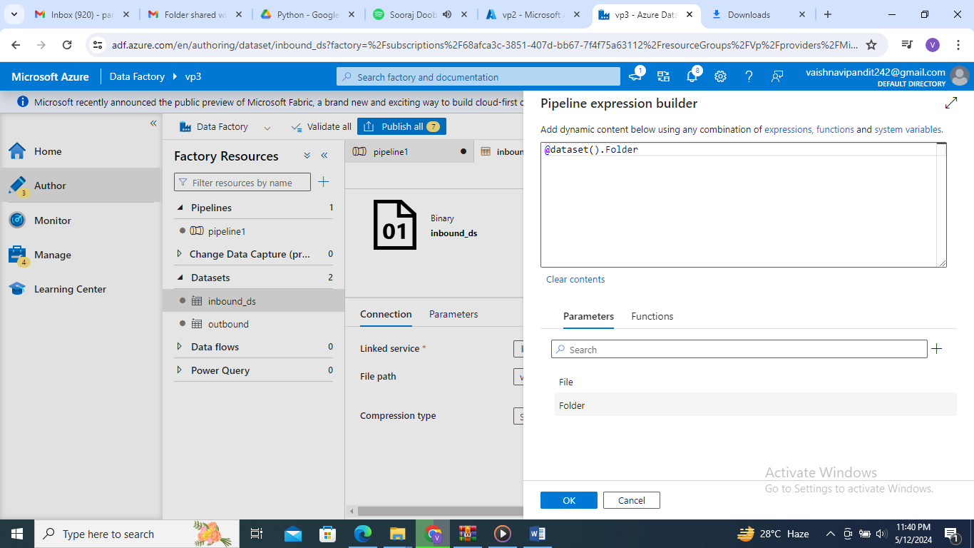

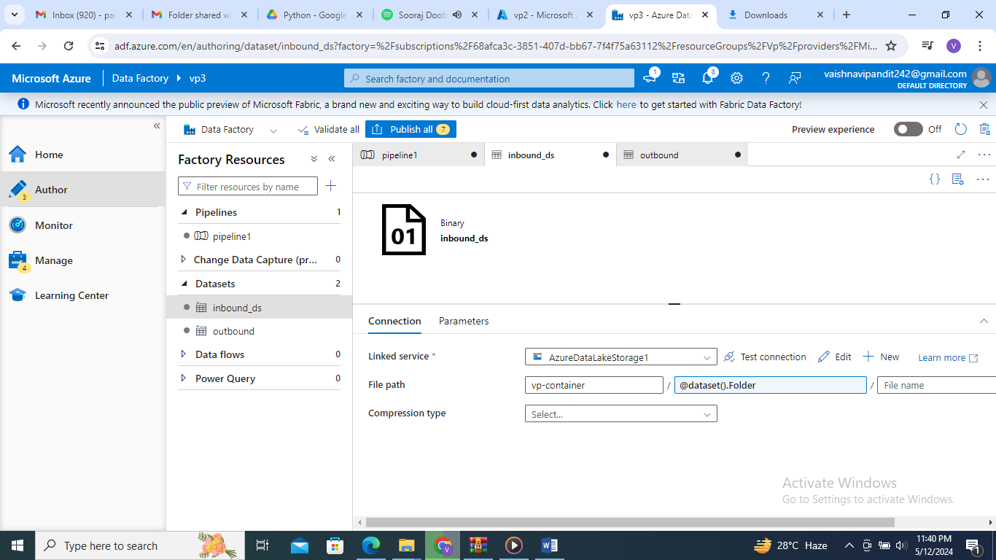

Similarly do for file as well

1. Similarly create datset for outbound or sink
2. Now drag and drop copy data in pipeline

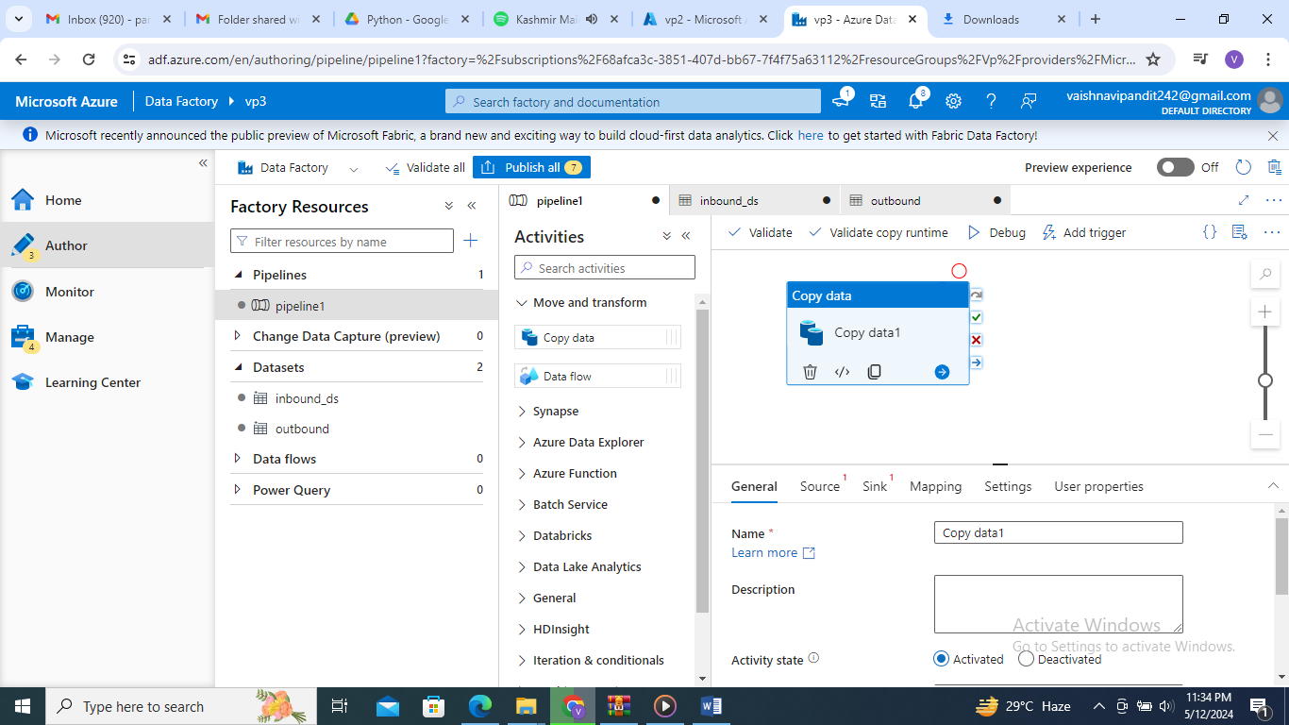

1. Add source

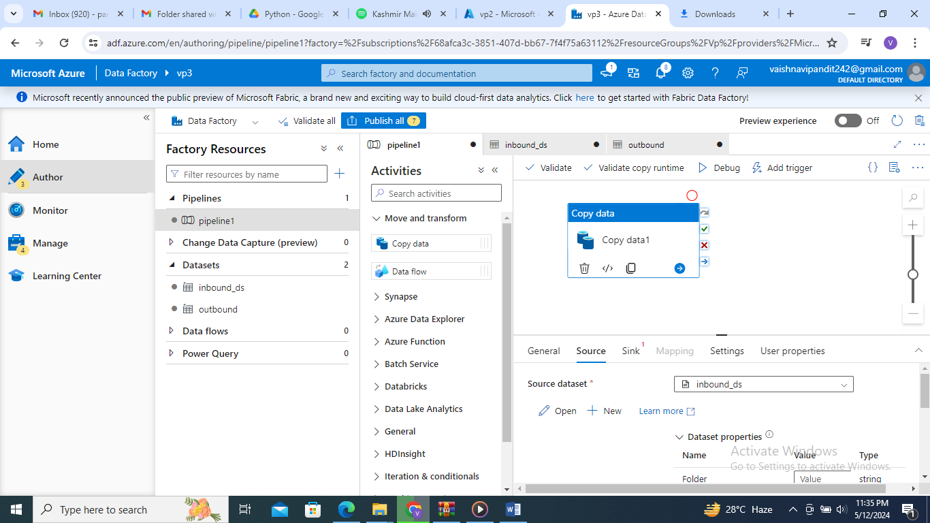

1. Add folder and filename in parmeters add folder name and filename

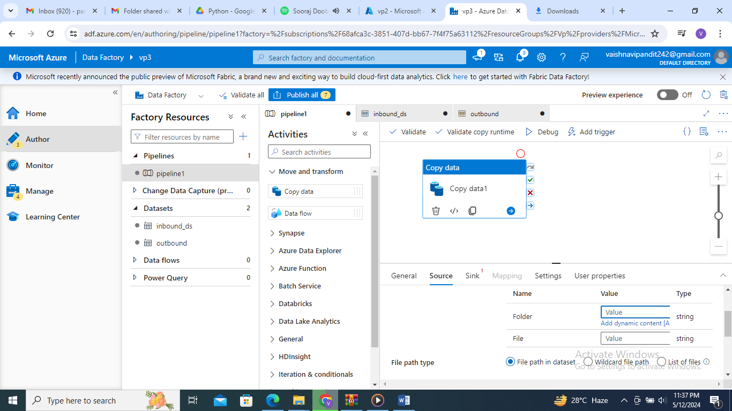

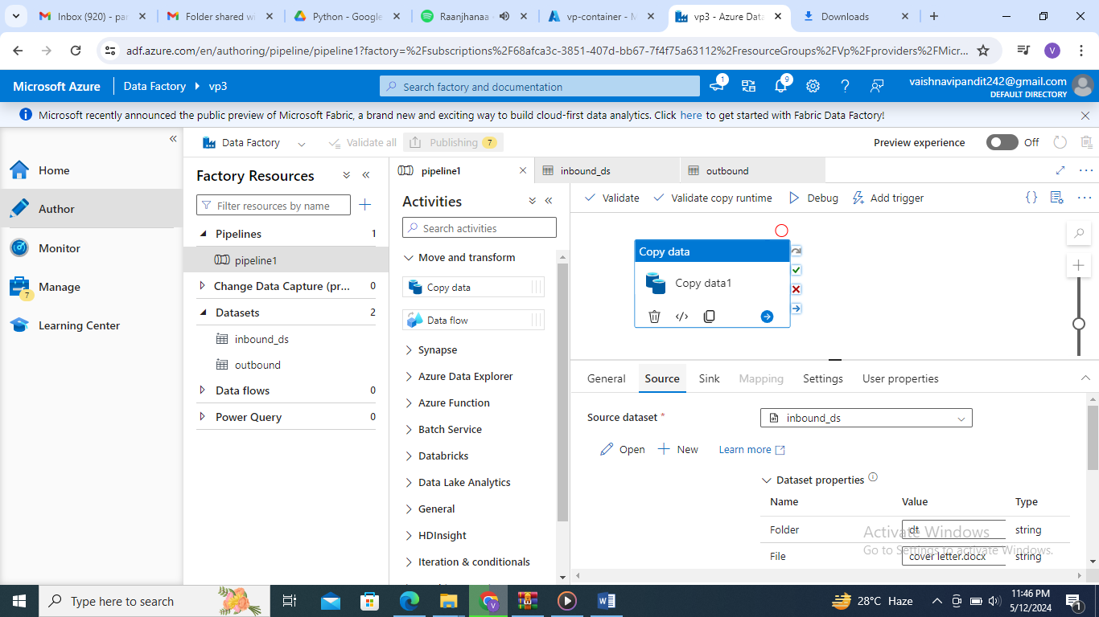

Similarly do for sink and publish and debug